**PERCEPTRON**

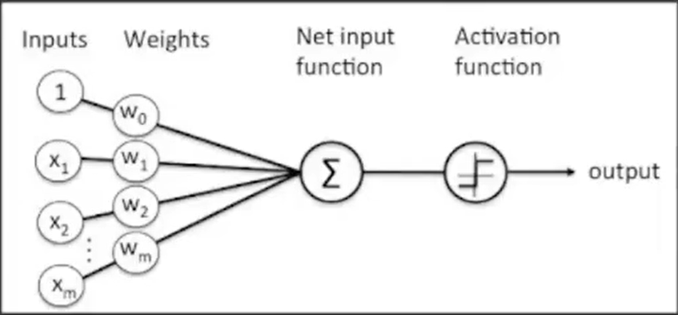

In the previous lecture, we learned that there are three types of neural networks ANN, CNN, RNN

The building block of ANN can be called **Perceptron** which got the inspiration from the Neuron of the human brain.

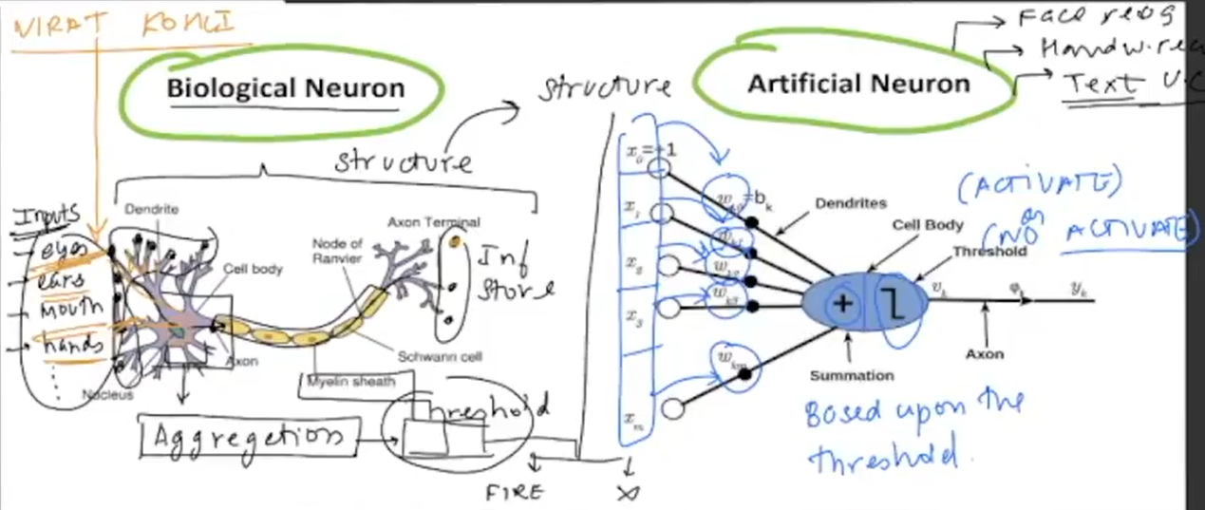

1. Perceptron is the building block of ANN
2. Works like a linear classifier but it is a stepping stone
3. Input (X1, X2, X3…) = Output(W1X1, W2X2, W3X3…), a linear combination further compared with the threshold. If the linear combination is greater than the threshold then it will be 1 otherwise it will be 0.

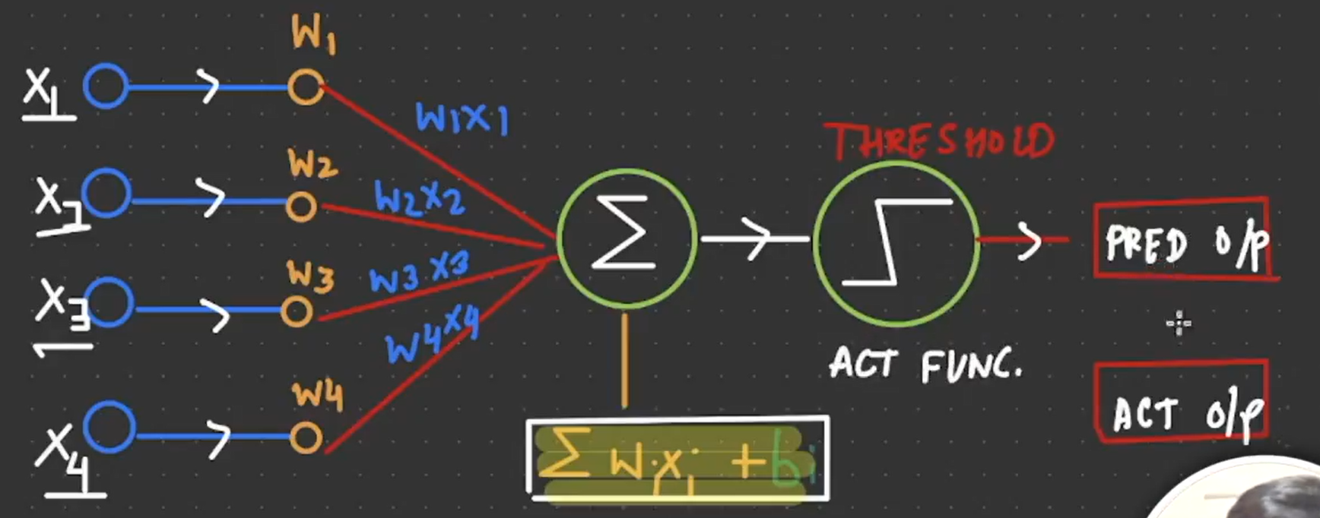

Here bi = Bias, and the threshold is an activation function like RELU, etc.

The difference between predicted and actual output will be an error. And with the help of the error, we will optimise or update the weightage.

**Logical Gates**

1. AND gate
2. OR gate
3. NOR gate
4. NAND gate
5. XOR gate, etc.

**AND gate**

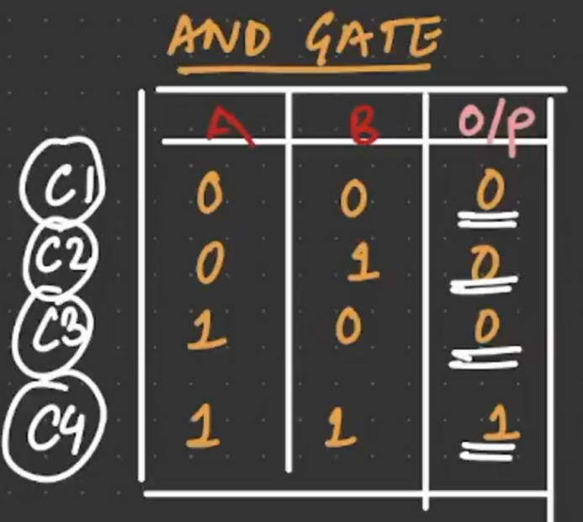

Now we need to see if the learning output is giving the same output or not.